Note for faculty: Though the article and common references on the internet uses the phrase autism; common medical and the patient advocates preferred term is ASD or (Autism Spectrum Disorder) in order to encapsulate the full experience range of this group of developmental disorders including Asperger’s. I suggest you use the term ASD in discussion, but when I refer to the text, I use the term used in the text.

This paper was retracted for both scientific fraud:-

- failure to disclose financial interest, including being paid by lawyers to produce scientific data supporting a vaccine syndrome;

- data in paper that does not match medical records of these patients;

- falsely reporting that they selected consecutive patients for study when they were actively selecting patients that supported their hypothesis

- falsely reporting that parents reported behavioral problems in children AFTER MMR vaccination when medical records show reports PRIOR to vaccinations.

and ethical concerns:-

- unnecessary medical procedures on patients including spinal taps;

- filed patent for alternative measles vaccine before publishing report.

- no prior approval by ethic boards to conduct research;

- no qualification to conduct the research;

-paying children to have their blood drawn during son’s birthday party.

On these grounds, the paper was retracted and the study is thoroughly discredited. Wakefield is also no longer allowed to practice medicine.

Furthermore, countless other studies have shown that there is no association between MMR and autism.

This paper is oftentimes used as ‘proof’ that vaccination is linked to autism. Aside from the overwhelming evidence above, let’s examine if it actually offers evidence of such an association. Here, we will use some of the skills we have learned in the previous exercise to examine the data reported in the paper.

What is the title of the paper?

Ileal-lymphoid-nodular hyperplasia, non-specific colitis, and pervasive developmental disorder in children.

Using google, define hyperplasia and colitis.

Hyperplasia =enlargement of an organ or tissue by an increased proliferation.

Colitis= colon inflammation

Does the title of the paper mention vaccination?

No. (How does this relate to what the students have heard/their expectactions about this paper, that it shows a link between vaccination and ASD?)

Read the summary. What are the associations that this paper is seeking to show? (Hint: it’s more than two things).

That there are associations between MMR vaccination, Autism (or onset of behavioral problems) and various gastrointestinal problems.

What is the total sample size in the paper to show these associations?

12 children. All were diagnosed with autism.

Based on what you have learned, do you think this sample size is big enough to vigorously test these associations?

No. (This is a slightly more complicated argument than what they have done before. As an example, say instead of just examining difference in taste between brown M&Ms and other colors, they also examined a number of other differences, including the way the M&M feels in their hands, how quickly it melts, the size, the shape, the weight etc. The more variables and tests you do, the more likely you are to find a difference between the two. By probability alone, even with a 95% confidence interval, if you examine 100 variables, there is a good chance that a number of them will show you difference, even if no difference exists. There are two ways to handle this. Either your sample size needs to be very large, or you need to verify with a second data set whatever differences you found in the first data set/experiment. Neither of those were done here.)

Let us look at one of these associations. Let’s say you are interested in looking at the association between MMR vaccination and autism.

Out of the 12 patients in this study, how many had MMR vaccinations (table 2)?

All 12 (Data is in both the ‘exposure identified by parents or doctor’, and in the ‘interval from exposure to first behavioural symptoms’ columns.

How many of the study participants were diagnosed with autism or displayed behavioral problems?

All 12.

If you were interested in studying association between autism and MMR vaccinations, is this an appropriate data set? Is this a controlled study? What groups of patients are missing to have this be a controlled study?

No. There are no participants here who have had the MMR vaccination and were not diagnosed with ASD, or patients who did not have the MMR vaccination, and were diagnosed with ASD. Therefore, you cannot tell if there is indeed association between ASD and MMR vaccination. In page 641, second paragraph of the left hand column, the authors admit as much.

“We did not prove an association between measles, mumps, and rubella vaccine and the syndrome described.

Virological studies are underway that may help to resolve this issue.

If there is a causal link between measles, mumps, and rubella vaccine and this syndrome, a rising incidence might be anticipated after the introduction of this vaccine in the UK in 1988. Published evidence is inadequate to show whether there is a change in incidence or a link with measles, mumps, and rubella vaccine.”

One argument in the anti-vax movement is that there is an association between increase in autism diagnosis and an increase in MMR vaccination. This is actually NOT TRUE. For example, graph below. Note here that though the number of diagnosis of autism increased by almost 600%, but the vaccination rate only increased by 50%. Why do students think that the rate of diagnosis of ASD has increased so dramatically?

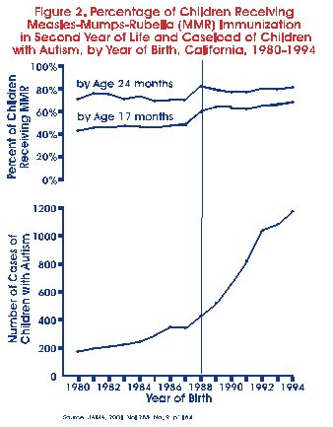

California, 1980 to 1994.

Dales, L, et al., "Time Trends in Autism and in MMR Immunization Coverage in California" *JAMA* 2001;285:1183-5

Another common belief is that ASD is related to glyphosphate herbicides. One common graph they might see is found below, suggesting a correlation between the two. However, correlation is not causation. For example, you can just as easily plot sales in organic food to ASD. (graphs and argument taken from https://www.geneticliteracyproject.org/2015/10/13/autism-increase-mystery-solved-no-its-not-vaccines-gmos-glyphosate-or-organic-foods/)

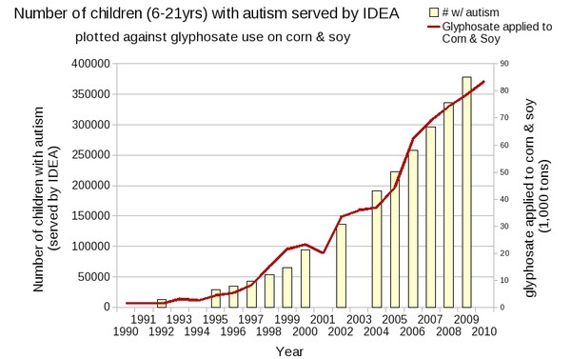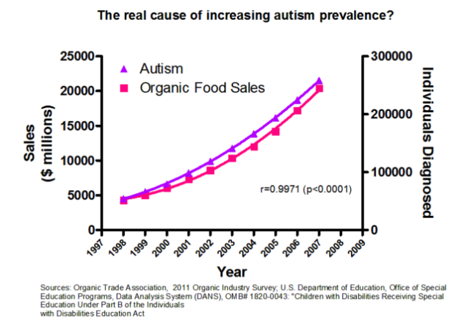

Ultimately, even without the scientific fraud and ethical violations, did the authors present scientific evidence that supports the hypothesis that ASD is linked to MMR vaccination? Did they provide evidence that MMR vaccination CAUSES ASD?